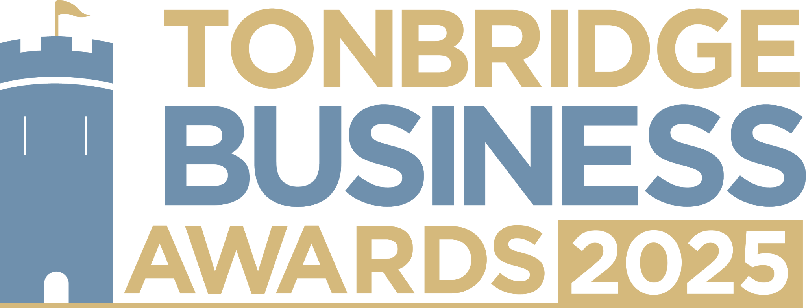

**New Business of the Year.** Has your business begun trading since June 2023? We would love to hear about what inspired you to start your business and what you’ve achieved so far. All information provided will be kept confidential and applications will be reviewed only by our judging panel and team. Please submit your entry form to [**info@thetncard.com**](mailto:info@thetncard.com)before 5pm on 6th May.

**1. Business information**

|  |  |  |  |
| --- | --- | --- | --- |
| Business name: |  | | |
| Business address: |  | | |
| Date started: |  | No. of employees: |  |
| 2024 turnover:  Optional - enables judges  to assess growth |  | 2023 turnover: Optional - enables judges to assess growth |  |
| Website address: |  | | |
| Social media links: |  | | |

**2. Applicant information**

|  |  |
| --- | --- |
| Name: |  |
| Role: |  |
| Email and phone number: |  |

**3. About your business**

3a. When was your business officially launched? Maximum 100 words.

3b. Describe your business in one sentence.

3c. What inspired you to start your business? Maximum 300 words.

3d. What makes your business unique or different from your competitors? Maximum 300 words.

**4. Achievements and future plans**

4a. What milestones or successes has your business achieved so far? Maximum 300 words.

4b. Have you introduced any innovative ideas, products, or strategies? Maximum 300 words.

4c. What are your plans for the business in the next 1-3 years? Maximum 300 words.

**5. Sustainability and community**

5a. Do you have sustainability or ethical practices in your business? Maximum 300 words.

5b. Are you involved in any local partnerships or community work? Maximum 300 words.

**Terms and conditions.**

By submitting this entry form you consent to the following:

Our entry deadline is 5pm on Tuesday 6th May 2025. Entries received after this date will not be considered.

The Tonbridge Business Awards is open to businesses registered in postcodes TN9 – TN12.

The comments made on your application form and any supporting evidence must be accurate and may be fact checked. Evidence or further information may be requested.

Our judges’ decision is final. We are unable to give feedback on applications and entries are not returnable.

By entering the Tonbridge Business Awards, you are agreeing to participate in publicity for the awards including the use of any photography taken before or at the event.

Finalists are requested to attend the Tonbridge Business Awards evening at EM Forster Theatre on Thursday 26th June 2025. Please ensure you are available to attend prior to entering.