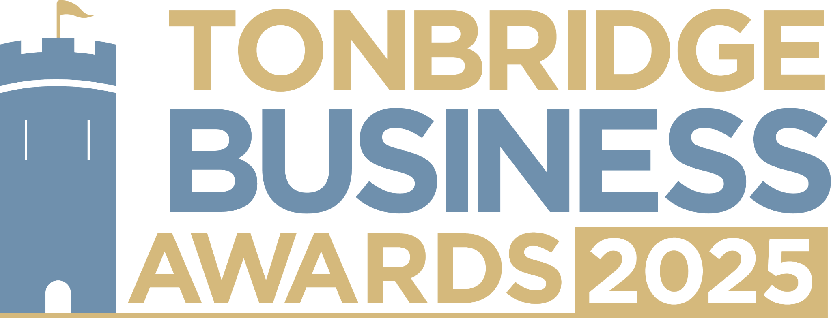

**Large Business Award.** Are you the owner of a large business with a workforce of ten or more people? We would love to hear about your growth, development of staff and what sets you apart in your industry. All information will be kept confidential, and applications will be reviewed only by our judging panel and team. Please submit your entry to [**info@thetncard.com**](mailto:info@thetncard.com)before 5pm on 6th May.

**1. Business information**

|  |  |  |  |
| --- | --- | --- | --- |
| Business name: |  | | |
| Business address: |  | | |
| Date started: |  | No. of employees: Including owners and part-time staff |  |
| 2024 turnover:  Optional - enables judges  to assess growth |  | 2023 turnover: Optional - enables judges to assess growth |  |
| Website address: |  | | |
| Social media links: |  | | |

**2. Applicant information**

|  |  |
| --- | --- |
| Name: |  |
| Role: |  |
| Email and phone number: |  |

**3. About your business**

3a. Describe your business in one sentence.

3b. What products or services do you offer? Maximum 300 words.

3c. What sets your business apart from competitors? Maximum 300 words.

**4. Achievements and innovation**

4a. What major milestones or successes has your business achieved in the past year? Maximum 300 words.

4b. How has your business grown or evolved over the past year? Maximum 300 words.

4c. Have you introduced any innovative products, services, or business strategies? Maximum 300 words.

**5. Sustainability and community**

5a. How does your business incorporate sustainability into its operations, products, or services? Maximum 300 words.

5b. How does your business support the local community or charitable initiatives? Maximum 300 words.

**Terms and conditions.**

By submitting this entry form you consent to the following:

Our entry deadline is 5pm on Tuesday 6th May 2025. Entries received after this date will not be considered.

The Tonbridge Business Awards is open to businesses registered in postcodes TN9 – TN12.

The comments made on your application form and any supporting evidence must be accurate and may be fact checked. Evidence or further information may be requested.

Our judges’ decision is final. We are unable to give feedback on applications and entries are not returnable.

By entering the Tonbridge Business Awards, you are agreeing to participate in publicity for the awards including the use of any photography taken before or at the event.

Finalists are requested to attend the Tonbridge Business Awards evening at EM Forster Theatre on Thursday 26th June 2025. Please ensure you are available to attend prior to entering.