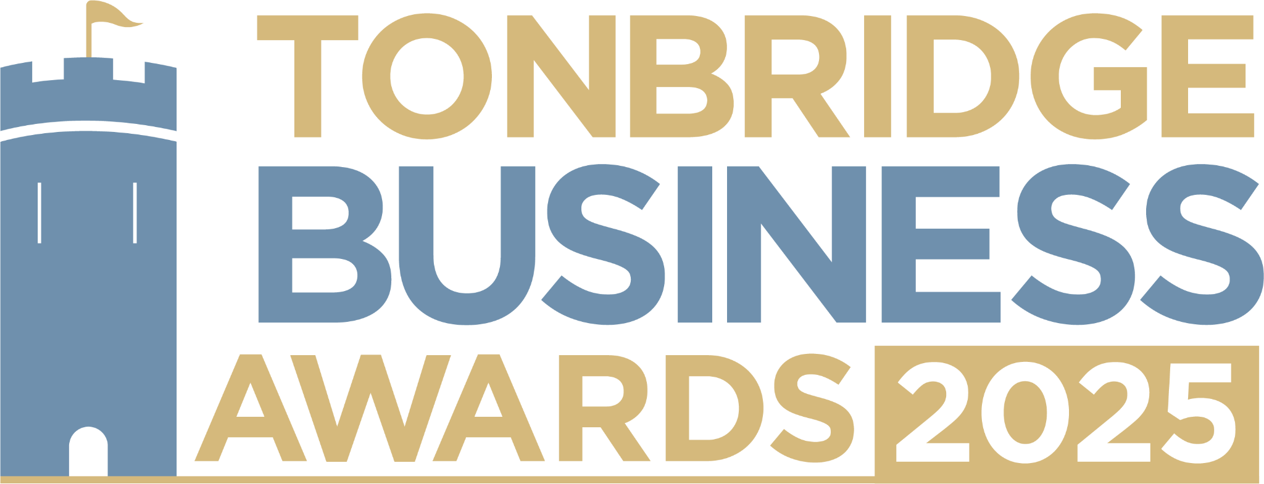

**Hair and Beauty Award.** Are you an owner of a business in the hair and beauty industry? We would love to hear about what sets you apart in your sector and all you’re doing in our community. All information provided will be kept confidential and applications will be reviewed only by our judging panel and team. Please submit your entry to [**info@thetncard.com**](mailto:info@thetncard.com)before 5pm on 6th May.

**1. Business information**

| Business name: |  | | |
| --- | --- | --- | --- |
| Business address: |  | | |
| Date started: |  | No. of employees: |  |
| 2024 turnover:  Optional - enables judges  to assess growth |  | 2023 turnover: Optional - enables judges to assess growth |  |
| Website address: |  | | |
| Social media links: |  | | |

**2. Applicant information**

| Name: |  |
| --- | --- |
| Role: |  |
| Email and phone number: |  |

**3. About your business**

3a. Describe your business in one sentence.

3b. What hair / beauty services or products do you offer and who are your customers? Maximum 300 words.

3c. What makes your business unique in this sector? Maximum 300 words.

**4. Achievements and innovation**

4a. How have you demonstrated innovation and excellence in your industry? Maximum 300 words.

4b. How do you ensure excellent customer experience and satisfaction? Maximum 300 words.

4c. How do you stay updated with trends and industry standards? Maximum 300 words.

**5. Sustainability and community**

5a. Do you have sustainability or ethical practices in your business? Maximum 300 words.

5b. Are you involved in any local partnerships or community work? Maximum 300 words.

**Terms and conditions.**

By submitting this entry form you consent to the following:

Our entry deadline is 5pm on Tuesday 6th May 2025. Entries received after this date will not be considered.

The Tonbridge Business Awards is open to businesses registered in postcodes TN9 – TN12.

The comments made on your application form and any supporting evidence must be accurate and may be fact checked. Evidence or further information may be requested.

Our judges’ decision is final. We are unable to give feedback on applications and entries are not returnable.

By entering the Tonbridge Business Awards, you are agreeing to participate in publicity for the awards including the use of any photography taken before or at the event.

Finalists are requested to attend the Tonbridge Business Awards evening at EM Forster Theatre on Thursday 26th June 2025. Please ensure you are available to attend prior to entering.