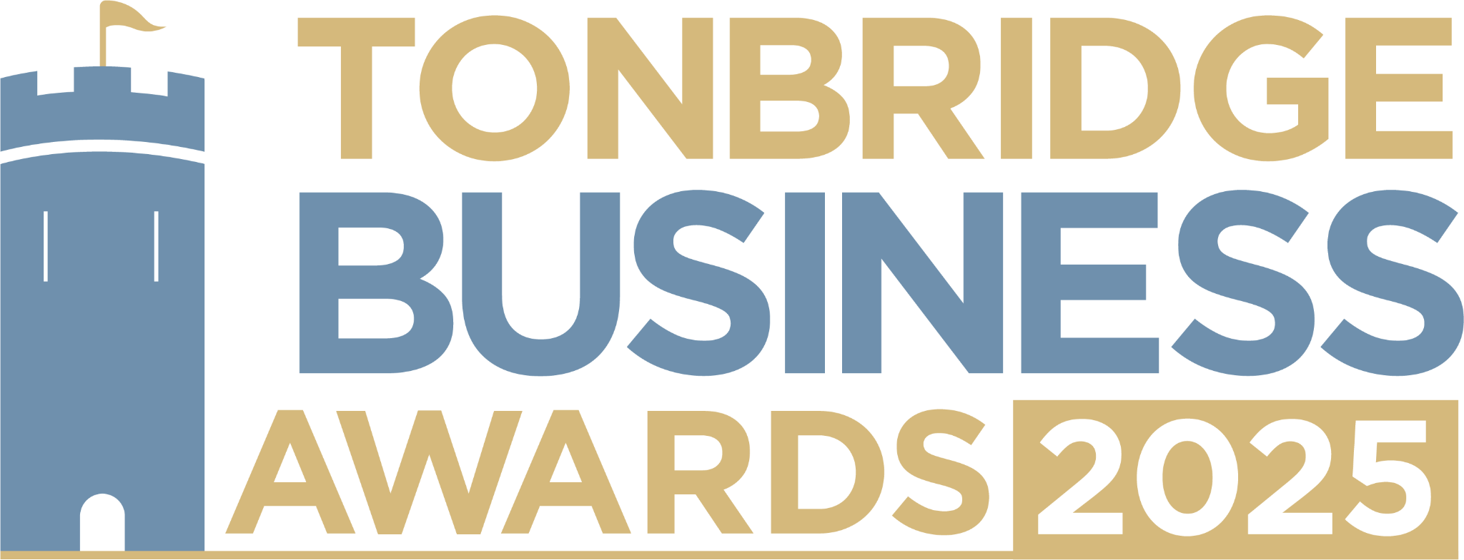

**Creative Business Award.** Are you an owner of a business in the creative, design, marketing or PR sector? We would love to hear about what sets you apart in your industry and all you’re doing in our community. All information will be kept confidential, and applications will be reviewed only by our judging panel and team. Please submit your entry to [**info@thetncard.com**](mailto:info@thetncard.com)before 5pm on 6th May.

**1. Business information**

|  |  |  |  |
| --- | --- | --- | --- |
| Business name: |  | | |
| Business address: |  | | |
| Date started: |  | No. of employees: |  |
| 2024 turnover:  Optional - enables judges  to assess growth |  | 2023 turnover: Optional - enables judges to assess growth |  |
| Website address: |  | | |
| Social media links: |  | | |

**2. Applicant information**

|  |  |
| --- | --- |
| Name: |  |
| Role: |  |
| Email and phone number: |  |

**3. About your business**

3a. Describe your business in one sentence.

3b. What creative services or products do you offer? Maximum 300 words.

3c. What makes your business unique in the creative industry? Maximum 300 words.

**4. Achievements and innovation**

4a. What major milestones or successes has your business achieved in the past year? Maximum 300 words.

4b. What challenges have you faced as a creative business, and how have you overcome them? Maximum 300 words.

4c. Have you introduced any innovative ideas, techniques, or creative processes? Maximum 300 words.

**5. Sustainability and community**

5a. Do you implement any sustainability, ethical, or inclusive creative practices? Maximum 300 words.

5b. Are you involved in any community initiatives or collaborations? Maximum 300 words.

**Terms and conditions.**

By submitting this entry form you consent to the following:

Our entry deadline is 5pm on Tuesday 6th May 2025. Entries received after this date will not be considered.

The Tonbridge Business Awards is open to businesses registered in postcodes TN9 – TN12.

The comments made on your application form and any supporting evidence must be accurate and may be fact checked. Evidence or further information may be requested.

Our judges’ decision is final. We are unable to give feedback on applications and entries are not returnable.

By entering the Tonbridge Business Awards, you are agreeing to participate in publicity for the awards including the use of any photography taken before or at the event.

Finalists are requested to attend the Tonbridge Business Awards evening at EM Forster Theatre on Thursday 26th June 2025. Please ensure you are available to attend prior to entering.