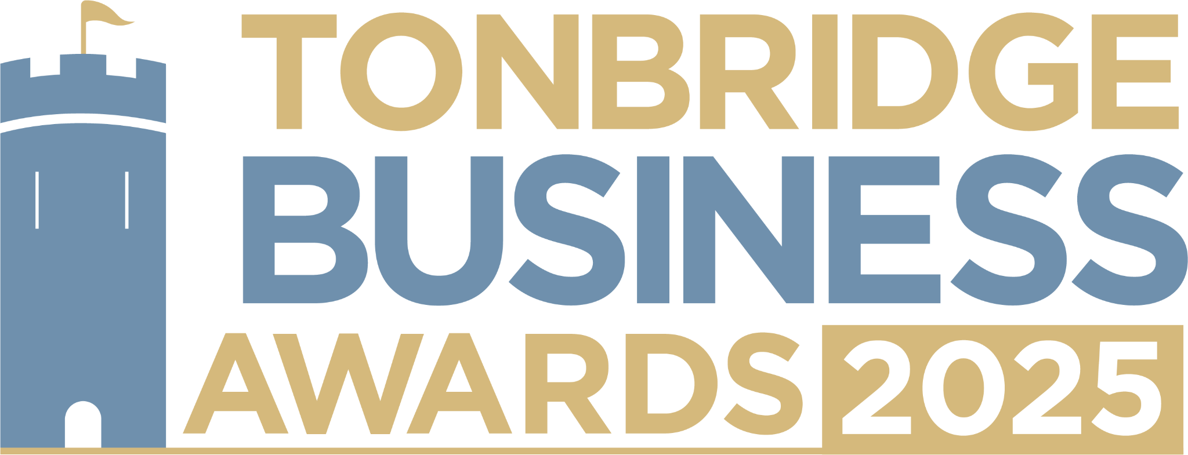

**Changemaker Award.** Our Changemaker Award recognizes businesses, organizations or individuals that are driving meaningful change in their community or industry. We would love to hear about how you’re leading with integrity, demonstrate a strong commitment to sustainability, and / or champion ethical business practices. All information will be kept confidential and applications be reviewed only by our judging panel and team. Please send your entry to [**info@thetncard.com**](mailto:info@thetncard.com)before 6th May.

**1. Business information**

|  |  |  |  |
| --- | --- | --- | --- |
| Business name: |  | | |
| Business address: |  | | |
| Date started: |  | No. of employees: Including owners and part-time staff |  |
| 2024 turnover:  Optional - enables judges  to assess growth |  | 2023 turnover: Optional - enables judges to assess growth |  |
| Website address: |  | | |
| Social media links: |  | | |

**2. Applicant information**

|  |  |
| --- | --- |
| Name: |  |
| Role: |  |
| Email and phone number: |  |

**3. About your business**

3a. Describe your business in one sentence.

3b. What products or services do you offer and who are your customers? Maximum 300 words.

**4. Ethical and community focused practices**

4a. How does your business operate with ethical principles and / or sustainability in mind? Maximum 300 words.

4b. How do you ensure your products or services have a positive impact on our community or the planet? Maximum 300 words.

4c. How do you make a difference to Tonbridge life? Maximum 300 words.

**5. Innovation and growth**

5a. What innovative solutions or approaches has your business introduced to make a difference, either socially or environmentally? Maximum 300 words.

5b. What are your future goals for continuing to create positive change through your business? Maximum 300 words.

**Terms and conditions.**

By submitting this entry form you consent to the following:

Our entry deadline is 5pm on 6th May 2025. Entries received after this date will not be considered.

The Tonbridge Business Awards is open to businesses registered in postcodes TN9 – TN12.

The comments made on your application form and any supporting evidence must be accurate and may be fact checked. Evidence or further information may be requested.

Our judges’ decision is final. We are unable to give feedback on applications and entries are not returnable.

By entering the Tonbridge Business Awards, you are agreeing to participate in publicity for the awards including the use of any photography taken before or at the event.

Finalists are requested to attend the Tonbridge Business Awards evening at EM Forster Theatre on Thursday 26th June 2025. Please ensure you are available to attend prior to entering.