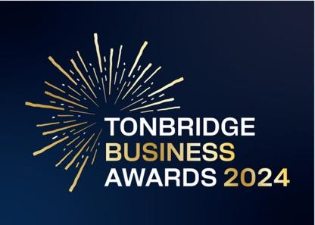

ENTRY FORM: ETHICAL BUSINESS
Are you an owner of a business that can demonstrate their commitment to ethical practices? We would love to hear about your implementation of practices that not only reduce your environmental impact but make a difference to people and our community. Please note: All information provided will be kept strictly confidential and applications will be reviewed only by our judging panel and team.

1. Business information
Business name:
Business address:
Business sector:

Date started: |  | No. of employees:
2023 turnover: |  | 2022 turnover:
Website address:

Facebook: | @ | Instagram: | @
Other platforms: | @ | LinkedIn:

2. Applicant information
Name:

Position:

Email:

Telephone number:

3. Business overview

3 a. What does your business do? Give us a brief description of your products and / or services. Maximum 300 words.

4. Ethical business award.

4 a. How have you demonstrated your company’s commitment to environmental and social impact? Maximum 300 words.

4 b. How have you scaled your actions over the past year to make a greater impact and how are you looking to the future?

4 c. Why should you be considered for this award? Maximum 300 words.

Please submit your completed form to info@thetncard.com before 5pm on 29th April 2024.
Good luck and thank you for entering.

Terms and conditions of entry.
By submitting this entry form you agree to the following:
Our entry deadline is 5pm on Monday 29th April 2024. Entries received after this date will not be counted.
The Tonbridge Business Awards is open to all businesses trading in Tonbridge, postcodes TN9 – TN11.
The comments made on your application form and any supporting evidence must be accurate and may be fact checked. Evidence or further information may be requested.
Our judges’ decision is final. We are unable to give feedback on applications.
By entering the Tonbridge Business Awards, you are agreeing to participate in publicity for the awards including the use of any photography taken before or at the event.
Finalists are requested to attend the Tonbridge Business Awards evening at EM Forster Theatre on Monday 3rd June. Please ensure you are available to attend prior to entering.
Entries are not returnable.

